1. PreCompiled Query:- The query that will be compiled irrespective of whether it will be executed or not is called precompiled Query.
2. PreparedStatement :- It is child interface of Statement Interface. It holds the **precompiled query**. The query is either select query or non-select query.

Syntax:-



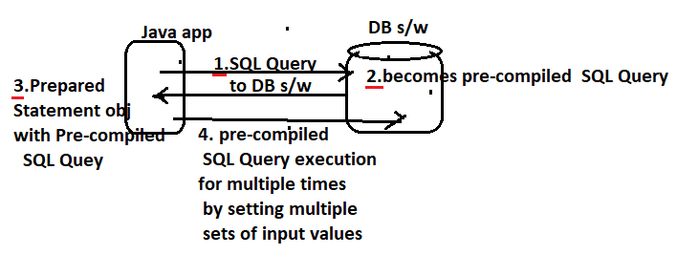

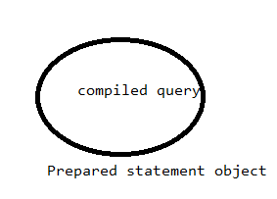

* 1. **Advantages By preparedStatement:-**

1. The SQL Query will be compiled only once, even though we execute the same query with same input and different input multiple times.
2. The SQL query can allows param(?). To them , the programmer supply values at run time.

(?) It is called param/IN Param/Placeholder. The param are having 1 base index. To which , we can set values later using following methods of preparedStatement interface.

setXXX(index of param);

where xxx represents datatype .

Ex:- insert into student values(?,?,..);

**The ? does not represent the tablename,colname and sql keywords.**

1. It allows both select query and non-select query as pre-compiled query.
2. It avoids SQL injection problem naturally.
3. It is suitable for inserting “date values”,”CLOB” and “LOB” type values.
4. Mostly , this prepared statement is used in real time.
   1. **Usecase:-**

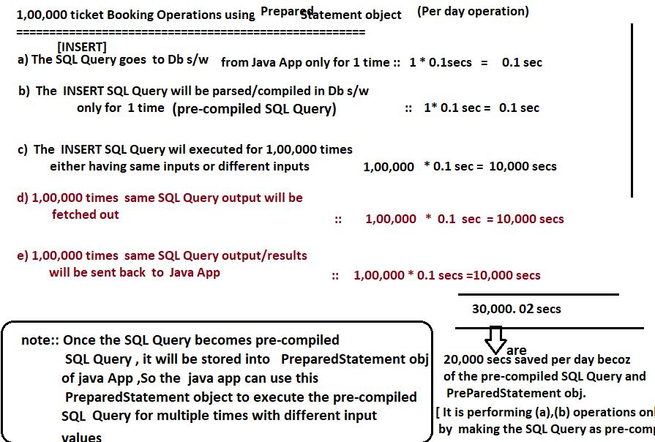

**Diff between simple statement and prepared statement.**

